Automating the process of data entry and applying the data according to specific conditions to a particular website

PROJECT STATEMENT :

Automating the process of data entry by applying the data from an excel sheet to a particular website.

ABSTRACT :

Data entry refers to the process of copying and applying data from an excel file to a particular website. Automating the process of data entry refers to the operation of entering the data from a excel sheet to a particular website. The term *data entry* has no specific technical meaning, but it implies that the data has been moved "forward" from a excel sheet to a new destination. With this project we can automate the process of data entry and reduce significantly the tedious amount of time taken by the workers. This project can help an organization gain more profit along with an efficient work.

FIELD OF PROJECT :

The project is in the field of Robotic Process Automation .Robotic process automation (RPA) is the use of software with artificial intelligence ([AI)](https://searchenterpriseai.techtarget.com/definition/AI-Artificial-Intelligence) and [learning](https://searchenterpriseai.techtarget.com/definition/machine-learning-ML) capabilities to handle high-volume, repeatable tasks that previously required humans to perform. These tasks can include queries, calculations and maintenance of records and transactions.

BACKGROUND OF PROJECT WITH REGARD TO THE DRAWBACK ASSOCIATED WITH EXISTING PRODUCT/PROJECT :

Automating the process of data entry refers to the operation of entering the data from a excel sheet to a particular website

The term *data entry* has no specific technical meaning, but it implies that the data has been moved "forward" from a excel sheet to a new destination.

With this project we can automate the process of data entry and reduce significantly the tedious amount of time taken by the workers.

This project can help an organization gain more profit along with an efficient work.

OBJECTIVE OF THE PROJECT :

The objective of the project is to reduce the workload on people who have to regularly enter the data from different excel sheets to a website based on specific conditions.

SUMMERY OF THE PROJECT :

In this project, we try to automate the process of data entry by automating the process of copying the data from an excel sheet to fill a form of particular website which is going to be stored in a database.

This project is going to reduce the human efforts and also reduce the cost of an organization significantly, thereby increasing their profit.

With this project we can automate the process of data entry and reduce significantly the tedious amount of time taken by the workers.

INTENDED BENEFICIARIES OF THE PROJECT (industrial/commercial/R&D/social) :

It would be most useful to the people responsible for entering the data regularly to a set of websites. This project intends to ease the work responsible for data entry.

PROJECT SNAPSHOTS :

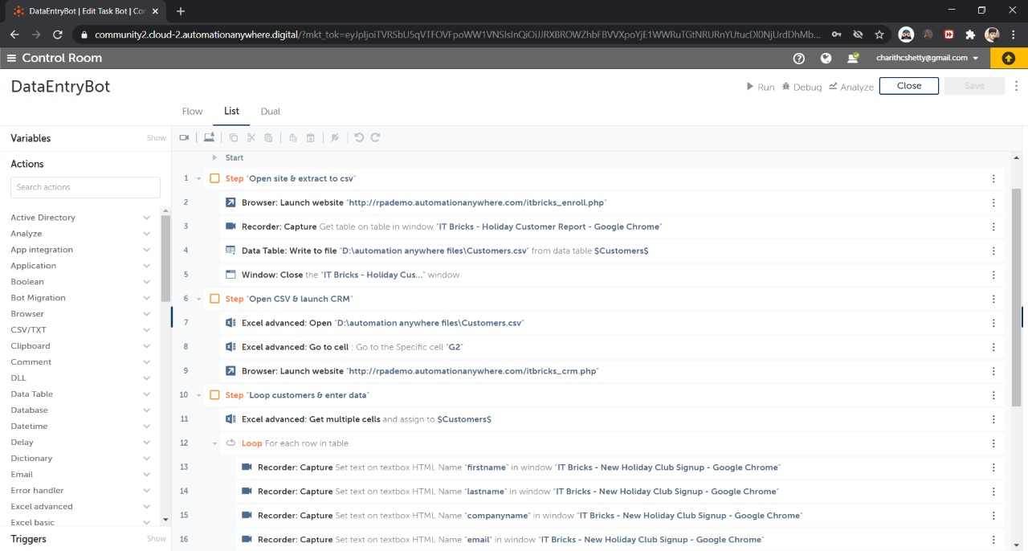

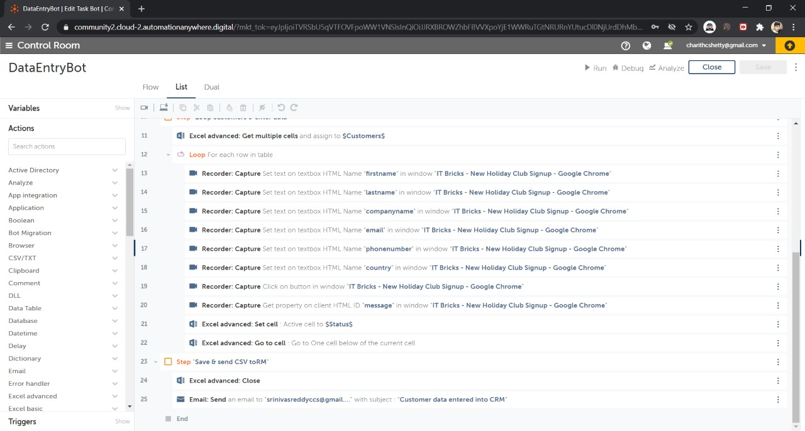

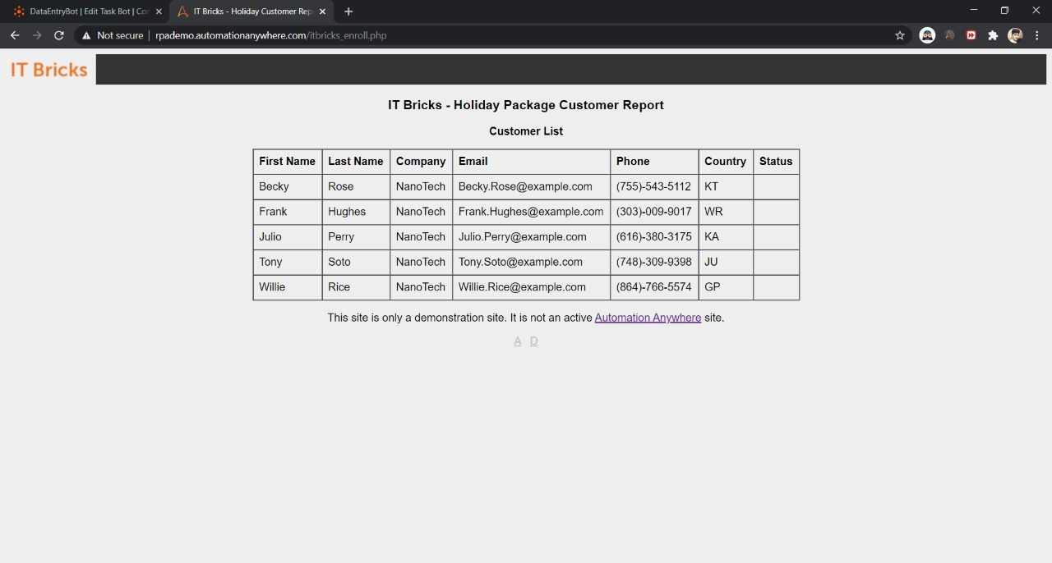

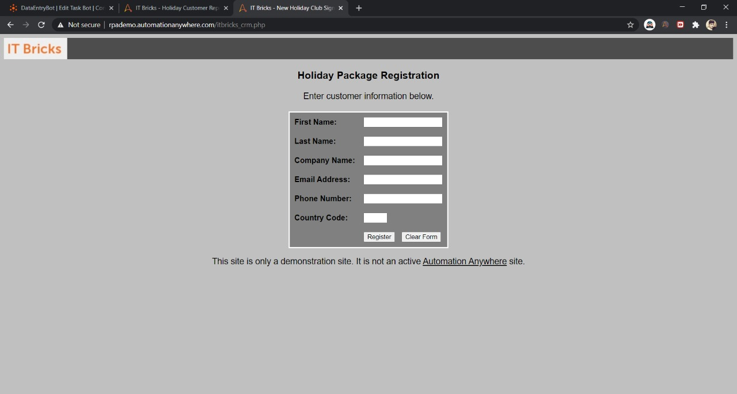

NAME OF STUDENTS AND COLLEGE :

Charith C Shetty (Dayananda Sagar College Of Engineering)

Deepak C A (Dayananda Sagar College Of Engineering)

Team : STOW

Batch-1

Sl. No. :-9